Save the completed report using the following format: Submit your report via email to the WFAA Executive Council and post your report to the WFAA website’s Meeting Minutes Index no less than 4 days prior to meeting.

WFAA Quarterly Officer/Committee Report 2019-2020
Executive Council Meeting Date |  |  | October 22, 2019
 |  |  | WFAA Yakima

Officer/Committee Information
Office Held/Committee Name: |  |  | Membership Chair
Officer/Committee Chair: |  |  | Tammy Zibell

Officer/Committee Goals for Service Year
Strategic Plan Goals that are being met (check all that apply)
Goal 1: Be a leader in providing training and professional development opportunities that are responsive to member needs
Goal 2: Maintain the long-term financial stability of the Association
Goal 3: Assess and monitor the performance of the Association and implement strategic Adjustments
Goal 4: Increase member participation in Association activities |  |  |  |  |  | X
Goal 5: Continually improve methods and processes for communicating with the membership |  |  |  |  |  | X

Goal 6: Consolidate and communicate the public policy positions of financial aid administrators in Washington State and provide members with support and education to further their own advocacy efforts

Goal 7: Maintain and enhance the diversity of our membership and the Executive Committee
Goal 8: Collaborate and coordinate with other organizations and associations in order to serve our members more efficiently and effectively |  |  |  |  |  | X
Specific Officer/Committee Goals (Include progress toward goals and measurement of success.) |  |  | - Increase member participation.

Summary of Activities (Descending Chronological)
- 9-24-19 Worked with Sarah preparing Institutional Membership letter to be sent out to WFAA members.
- October 17, 2019 – We have 2332 Active Members
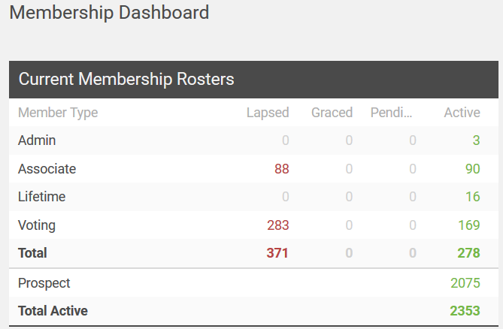

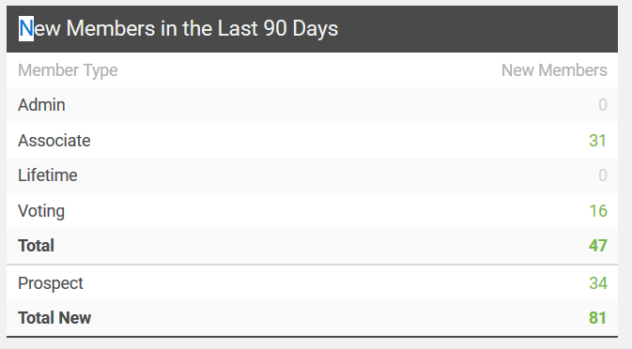
i
Budget Information
Approved Budget |  |  | N/A
Budget Expenditures to Date |  |  | N/A
Event Information (complete if applicable) |  |  | N/A
Event Name
Location
Date
 |  |  | Number | Cost of Registration | Subtotal
Attendees
Complimentary Registrations (if applicable – i.e., scholarship recipients)
Add more rows as needed for additional events.

Suggestions for Future Officer/Committee
Continue to find ways to increase WFAA Membership

Calendar of Events/Timelines
Date | Committee Member Responsible | Description

