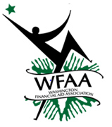

**At the Yakima Convention Center in Yakima, WA**

**October 10-12th, 2018**

**2018 WFAA Annual Conference**

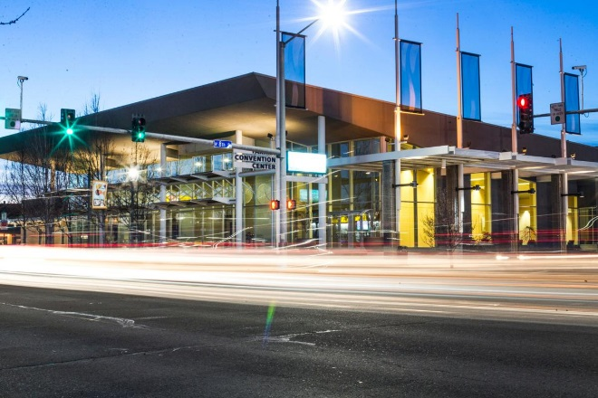

* Looking for a little gambling? Stop by the Caribbean or Legends Casino!

**THINGS TO DO IN THE AREA:**

This year’s conference will be located in the beautiful town of Yakima at the Yakima Convention Center. The conference will give you an opportunity to not only develop as a professional, but to network and explore the wonderful Valley of Yakima. This year’s agenda will include presentations from our regional (WASFAA) and national (NASFAA) professional organizations, as well as interest sessions from federal and state leaders. The keynote speech on Wednesday, October 10th, will be from Roger Fernandez, a Native American Artist and storyteller.

*Roger Fernandes, or Kawasa, as his fellow members of the Lower Elwha Band of S'Klallam Indians near Port Angeles call him, has strong feelings about how stories should be shared.*

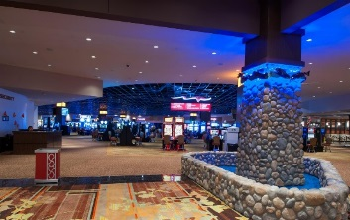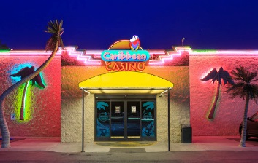

**Hotel Reservation Information:**

*"The true power of storytelling comes when the moisture of the teller's breath gives life and power to the story," Fernandes says.*

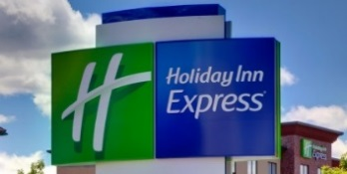

The **Holiday Inn Express** conference rate is $93 for a single occupancy or $113 for double occupancy, plus taxes and charges. Check-in begins at 3 p.m. and ends at 12 p.m. Reservations can be made by calling the hotel directly at (509) 249-1000 and just give the name Washington Financial Aid Conference. **Hot breakfast bar included.**

Free parking available.

Complimentary Wi-Fi, fitness center, and indoor pool are included.

* Enjoy golfing? Visit the Suntides Golf Course



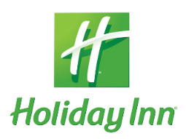

* Schedule a Wine Tour



The **Holiday Inn** conference rate is $93 for a single occupancy or $113 for double occupancy, plus taxes and charges. Check-in begins at 3 p.m. and ends at 12 p.m. Reservations can be made by calling the hotel directly at (509) 494-7000 just give the WFAA Conference name and dates. **Breakfast not included.**

Free parking available.

Complimentary Wi-Fi, fitness center, and indoor pool are included.

**Make your reservation for either hotels by September 5th for the WFAA Conference rate.**